Optimal Coteries for Rings and Related Networks
Toshihide Ibaraki, Hiroshi Nagamochi, Tsunehiko Kameda
DISTRIBUTED COMPUTING, VOL. 8, 1995 pp.191-201
Abstract
The availability of a coterie is defined as the probability that the operational nodes and links of G connect all nodes in at least one subset in the coterie. In this paper we show that, if G is a ring, either a singleton coterie or a 3-majority coterie is optimal. Therefore, for any ring, an optimal coterie can be computed in polynomial time. This result is extended to the more general graphs, in which each biconnected component is either an edge or a ring.
- Introduction
The availability of a coterie C with respect to G, denoted A_{G}(C), is defined as the probability that there is a connected subgraph G’=(V’,E’) of G consisting only of operational nodes and edges, such that S ⊆V’ for some S∈C.
- Preliminaries
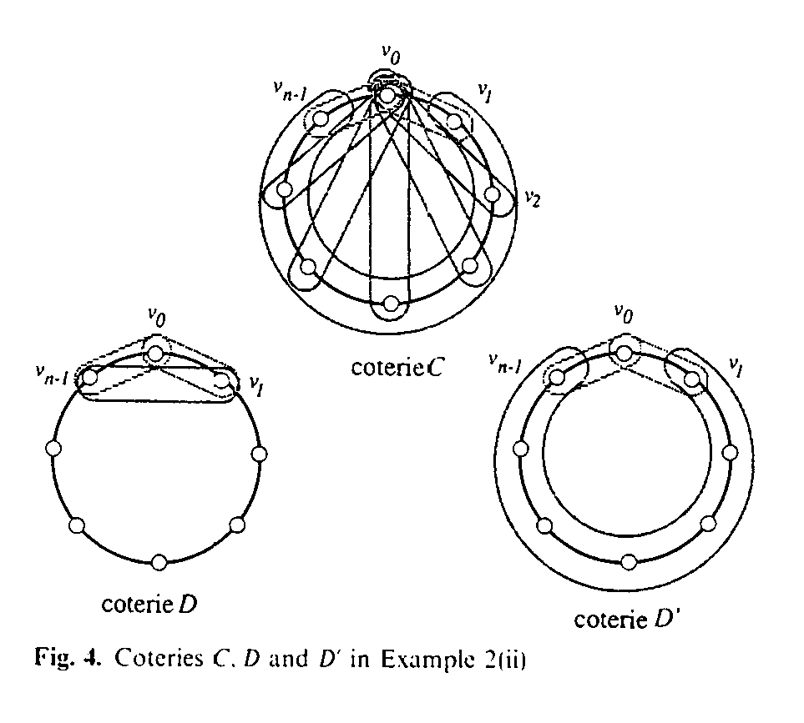
Both C and D dominates D’.
Coterie C is nondominated, and contains more quorums than coterie D’, which is do-minated.
Neither C nor D dominates the other. However, C, D and D’ are “equivalent” from the viewpoint of availability.
- Reduction to biconnected components
- Optimal coteries for a tree
Theorem 1. Given a tree G=(V ,E), suppose that, for each I, node vi∈V is operational with probability p_{i}. Then, a singleton coterie C={{v_{i0}}}, where
p_{i0} = max {pi},
is optimal.
- Optimal coteries for a ring
Theorem 2. If G is a ring, then there is an optimal coterie which is either a singleton coterie or a 3-majority coterie.
Theorem 3. If G=(V, E) is a ring, and p_{i}=p for all i=0, 1, …,n-1, then either a singleton coterie or a 3-majority coterie C₃ such that V(C₃) consists of three consecutive nodes on G is optimal.
- Conclusion

Created by : Kwo-Tsung Tseng
Date : Oct. 8, 1998

